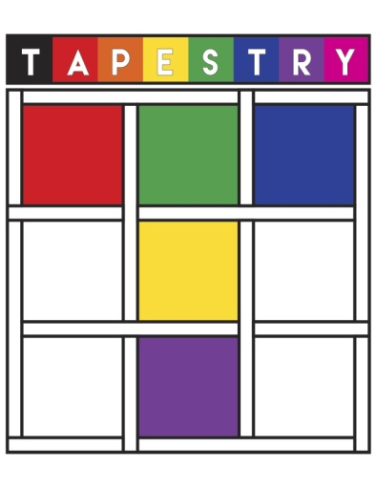
TAPESTRY Friday February 15, 2019
FACILITATOR BIOGRAPHY & PROPOSAL

Deadline for Submissions: Monday, November 19th, 2018
Please note that workshops with less than 10 registered
participants will be cancelled.
All proposals are brought to committee for approval.

PRESENTER INFORMATION
Name:

Email:

Address:

Telephone Number:

Personal Biography:
(to appear in the conference brochure)
Fee:

WORKSHOP INFORMATION
Title:

Target Audience:

Summary:
(To appear in brochure.)

Length of Presentation:  (Please select one) | - Morning - 1 hour and 45 minute session  - Afternoon - 1 hour and 45 minute session  - All Day Session - 3 hours and 30 minute session
Equipment Required:

Please email to tapestry@gvta.net

